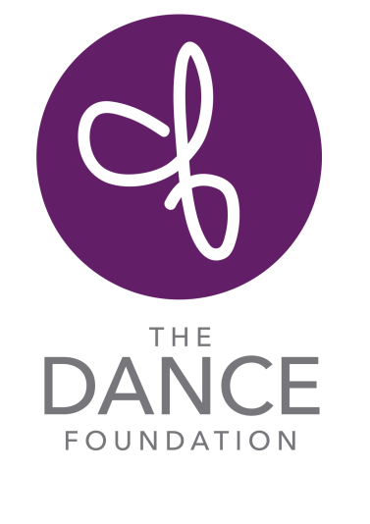
Teachers Needed for Dance Classes
Work available starting January 2019: The Dance Foundation is seeking dance teachers for classes in creative movement, ballet and modern for preschool-2nd grade students. Teachers must enjoy teaching young students, embracing imaginative work as part of the curriculum, along with collaborating with a musician. Teachers must embrace the spontaneity of young children and bring creativity and enthusiasm to each class. Classes are taught in our state of the art studios as well as in community settings. Training in our curricula and professional development opportunities are provided. Candidates are requested to send a resume with an email message detailing availability (mornings, early afternoons, after school hours) in January – May as well as June - August to: Blakely Cottle, Blakely@@thedancefoundation.org. More information about us may be found at: www.thedancefoundation.org.

