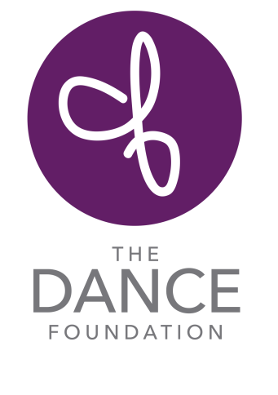
Internship Opportunities – Summer ‘19

Our Mission: to teach the art of dance to all, inspiring creativity and confidence.

Our Story – Our Impact: The Dance Foundation’s programs spark creative thinking, encourage collaboration and build confidence in the lives of children, teens and adults in Birmingham through dance. Our dance classes and performances inspire all involved – the growing toddler, the child who is homeless, disadvantaged or at-risk, the child who has special needs, and the inquisitive teen. What began in 1975 as a new approach to teaching dance to young children of all abilities and circumstances has flourished into something extraordinary. The Dance Foundation is an organization now serving more than 2,000 students each week through our Community Partnership Program and Studio Program. The Dance Foundation is also home to dozens of artists and arts organizations for classes, workshops, rehearsals and performances with our Studio Use Program for Community Artists.

Internship Needs

Teaching Assistants and Program Support (Assisting the Artistic Director)
Students in high school and college are needed for summer internships and volunteer work. Commitments range from assisting with studio classes for children with special needs to half and full day summer camps for students ages 4 to 6th grade. Students who may be well-suited for these internships are those with experience working with children, studying dance and theatre, education, special education, physical therapy, teaching English as a second language, and kinesiology. Students with dance experience but studying in other fields are also good candidates for these internships. One or more students needed; depending on the program, days and time may vary week to week. Please send your resume and availability details in the email inquiry.

Contact Blakely Cottle: Blakely@thedancefoundation.org .

1715 27th Court South / Birmingham, AL / 35209 / 205.870.0073 / www.thedancefoundation.org

